**Index Page**

**The Christmas Season is upon Us!**

**. . . and we are ready!**

We send flowers World-Wide with. [](http://www.bing.com/images/search?q=ftd+logo&view=detail&id=21D6B516373138C1E98D40024E46BC26EFCD6EE3&first=0)

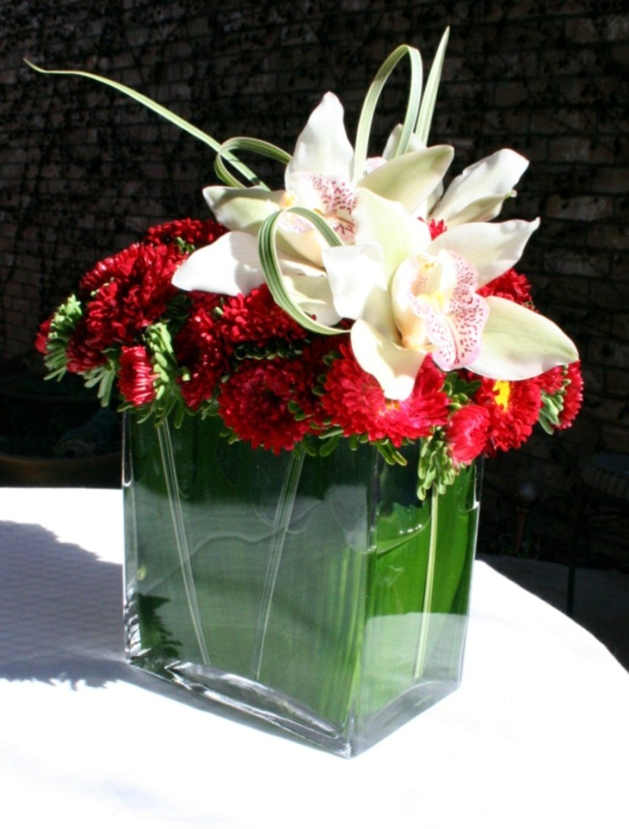

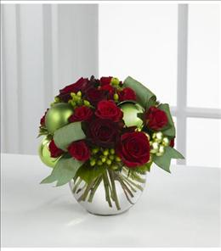

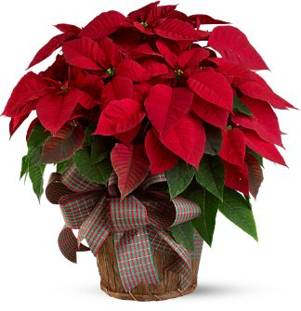

Plants in a Birch Container

Rounded Rose Bowl

Rose & Orchid Vase







Roses & Orchids

Wreath

Carnations & Roses in a Black

Birch bark Vases

Traditional bouquet

Classic bouquet

$100.00 bouquet

